Computer Language Diagrams

Referrers in a Diagram
The concept of referrers was explained in the article Referrers. This article only explains its display in a diagram.

The referrers of an object are simply displayed as a sub-list called Referrers, every item of which points back to the objects referring to the object:

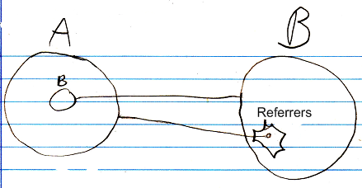

The lines coming out of the referrers list are usually not shown, because a line tied to an object already implies a referrer. The diagrams will have more features later, and the referrer lines would obscure the picture.

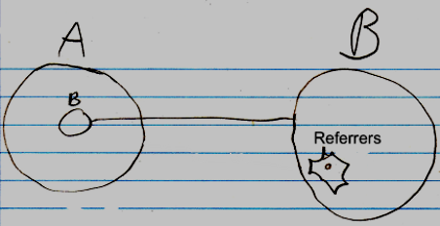

Even the whole referrers list may even be left out of the diagram by default, but it is not clear yet, if that is the way to go.

Implementation as a concept
As explained in the article Referrers, the implementation of referrers as a concept requires extension of related item’s Object . Set procedure, so that a referrer is added to the other object’s Referrers list and the Referrer ID In Object is recorded.

The adapted system interface would look something like this in a diagram:

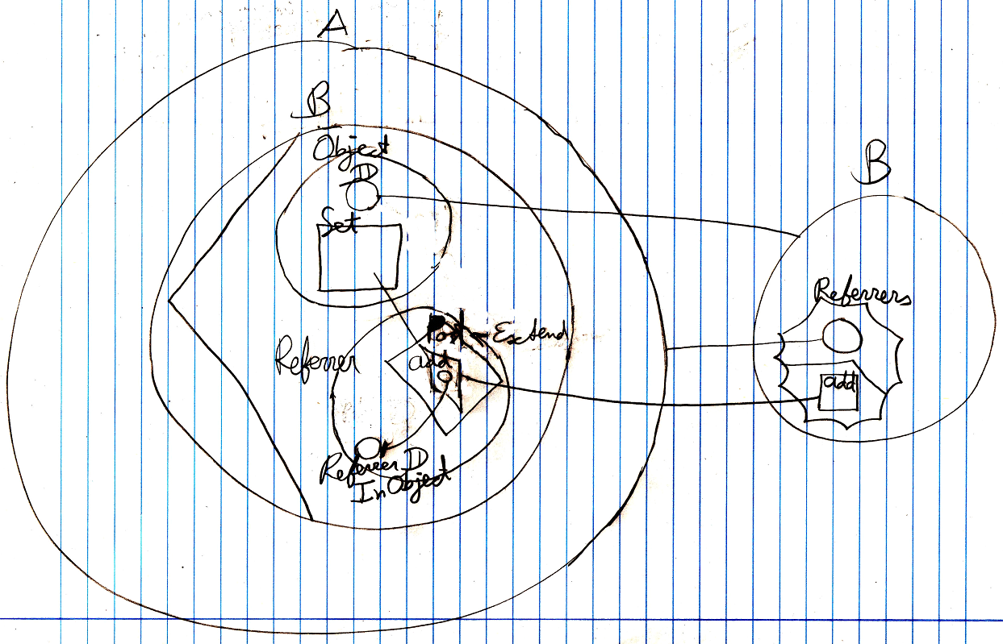

It is just a demonstration of extension of the system interface. Not all the details are shown above. By showing the system interface you can see exactly see how the Referrers list is updated. Fortunately you can hide the system interface, so that it looks simple again:

Showing the system interface gives you a view on the inner workings of the Referrers concept. Further details won’t be discussed here. It is just an example of a concept extending of the system interface.

See also: Referrers

Author & Copyright: Jan-Joost van Zon Date: June 8, 2008 – June 8, 2008 Location: Oosterhout, The Netherlands Status: Finished

